Griffin Elementary November 11, 2011

The Endsley Edition

Thank you for attending conferences last week. I really do love talking about all the growth that the students have made so far. Our class had 100% participation. I really appreciate all of you for making time for this in your schedules. It makes a big difference in your child’s education.

Candy Giveback! Griffin school won the Candy Give-back promotion! We not only earned pajama, popcorn and movie day, we also won money to replace some soccer nets on the playground. We are all very excited! Thank you so much to all of you for supporting this effort!

Picture Retakes: Re-take day is Nov. 17th. A note is in your child’s Friday Folder. You will need to return the originals in order for your child to have his/her picture taken. Thanks

Winter Wear and Share: This is a great program...ANYONE can participate! Feel free to drop off your clean, gently used winter outerwear beginning today! Stop by the week of Nov. 14th for items you may need for your family. This is a free service; you do not need to donate an item in order to take some items. Stop in! Nov. 14-18th

Save the Date: Our class will be hosting a Holiday Tea on Tuesday, December 13th from 2:45 – 3:45pm. We want you to have early notice in case you need to put in notice for work. It is a beautiful celebration! The 1st graders read, sing, and then we all get to spend some time together eating. Please put this on your calendar…we would love to have you! A formal invitation will go home next week.

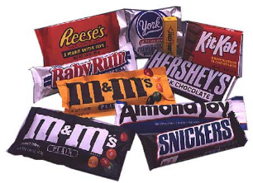 | If you haven’t done so yet, please send in five candy wrappers with your child. We will be making a fun project. For those that sent in extra…thank you! J
Important Dates…
Friday, Nov. 11 | Gym
Monday, Nov. 14 | Music, Winter Wear Share begins PTA Mtg, 7:00pm
Tuesday, Nov. 15 | Technology
Wed., Nov. 16 | Gym
Thurs, Nov. 17 | Music Picture Retake Day
Friday, Nov. 18 | Technology
Monday, Nov. 21 | Gym
Tuesday, Nov. 22 | Music
Wed., Nov. 23 | NO SCHOOL for students
Thurs, Nov. 24 | NO SCHOOL, Thanksgiving Recess
Friday, Nov. 25 | NO SCHOOL, Thanksgiving Recess
Monday, Nov. 28 | NO SCHOOL for students, Teacher In-service
Tuesday, Nov. 29 | Spanish ** School Resumes November Bday Lunch

Continued on the back

Math: We have completed through Unit 2! Refer to your homework book for activities. We took some extra time with subtraction, so that we better understand the concept. If you have questions, don’t hesitate to ask.
Science/Social Studies/Writing Switch: In writing this week, we were inspired by adventures with babysitters. We read the story, Don't Forget to Come Back by Robie Harris. Some students even added speech bubbles to make their writing more interesting. In Science this week, we started our study of the seasons with one of their favorites…summer! In Social Studies students learned about geography and the Earth’s surface.

Reading : In Reader’s Workshop this week we have continued learning that good readers ask themsevles questions while they read. I wonder…
This helps to bring meaning to the text and also helps us solve unknown words.
We continue to work on building our reading stamina. Right now our goal is to read for 25 minutes ! J

Retakes are November 17th!



The Family Turkey Projects are awesome! If you are still working on yours, send it in when you are finished. When you are in the building, stop by and check them all out! Very creative!
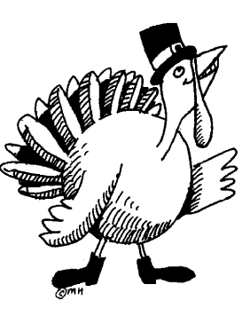

My email:
endsleyk@ghaps.org
Our website: www.mrsendsley.weebly.com
Have a great weekend!!

